INFORMATION FOR VENUES

ENTITLED

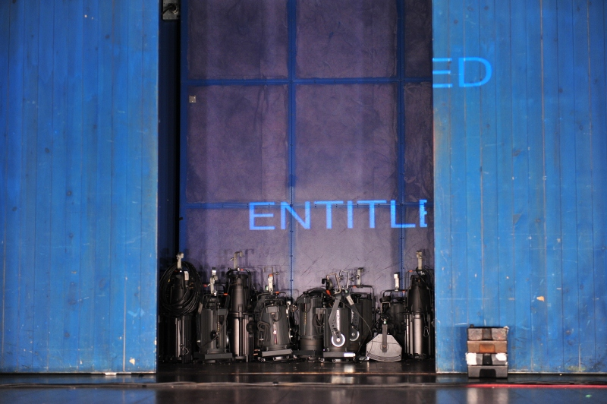

“It hums with quiet honesty, unflashy reveals, tender regrets and risk-taking”
The Guardian

“Hugely audacious”
The Stage

“What Richard Gregory and his company do is show that mankind is constantly reaching for something beyond its power.”
NRC Handelsblad, Netherlands Daily

Contents

- Box Office Briefing Notes
- Co-commissioning Credits
- Press Release
- Direct Mail
- Sales & Press pitches
- Audience Segmentation
- Press Quotes
- Information about Quarantine
- Media Available & Social Media Connections

Box Office Briefing Notes

Show: Entitled

Performed by:
Greg Akehurst
Joanne Fong
Sonia Hughes
John Kilroy
Lisa Mattocks
Chris Whitwood
Fiona Wright

Director: Richard Gregory
Designer: Simon Banham
Writer: Sonia Hughes
Choreographer: Jane Mason
Original Music: John Kilroy
Lighting Designer: Mike Brookes
Dramaturg: Swen Steinhauser
Philosopher: Dr Michael Brady
Assistant Director: José Miguel Jimenez

Production Manager: Greg Akehurst
Lighting Technician: Chris Whitwood
Stage Manager: Lisa Mattocks

For Quarantine:
Interim Executive Producer: Kully Thiarai
Associate Producer: Sam Stockdale

Suitability for a younger audience: There is no age restriction on Entitled although audiences should be aware there is some material that is adult in content.

Running times:
Approx 1 hour 45 minutes, no interval

Basic info:
Entitled is a studio-based theatre piece which takes the form of a theatre ‘get-in’ and ‘get-out’: the usually hidden choreography of transforming a theatre from an empty space into a stage for a show – and back again. This setting is used to explore questions about hope through a glimpse at the lives of the performers and technicians.

One sentence:
Entitled is about hope and disappointment, and how we try to make our life complete.

Co-commissioning Credits:

Entitled is co-commissioned by The Royal Exchange Theatre, Manchester, Sadler’s Wells and Curve Theatre in Leicester.

Entitled is a co-production with the Royal Exchange Theatre, Manchester.
Further developed with support from the Noorderzon Performing Arts Festival and the Grand Theatre in Groningen. Part of the 2011 Edinburgh British Council showcase.

Funded by Arts Council England.

Company contacts

Company office: 0161 830 7318

Production/Press/Marketing: Sam Stockdale
sam@qtine.com

Artistic Director: Richard Gregory richard@qtine.com

Production Management: Greg Akehurst greg@qtine.com

Request to venues:
Quarantine request that as soon as tickets go on sale weekly sales updates are sent to sam@qtine.com

Sample Press Release

Media Release

How do we make our lives complete? UK based theatre company Quarantine come to [insert Venue/Festival] with Entitled.

Entitled takes the form of a get-in and a get-out: the usually hidden choreography of transforming a theatre from an empty space into a stage for a show – and back again. It’s about hope, privilege and disappointment, and what we’re searching for to try and make our lives complete.

Artistic Director, Richard Gregory says: “Entitled puts three theatre technicians centre stage and invites us into their world. Its performers – including a dancer who’s finding her voice, a guitarist who used to be a dancer and a writer who wants to dance – step aside from their rehearsal to tell us what’s really going on in their lives. In some ways, it’s a show that never happens – asking us to think about how we live right now, rather than looking to the past or the future ”

Quarantine is interested in asking questions about who should be seen on stage and who theatre is for, making theatre that is bold and ambitious yet widely accessible. Their work is about the here and now. Past projects have included shared meals, family parties and a journey in the dark for one person at a time – as well as performances on stage, watched by audiences in seats.

“What Richard Gregory and his company do is show that mankind is constantly reaching for something beyond its power.”
NRC Handelsblad, Netherlands Daily

Entitled premiered in Manchester at the Royal Exchange Theatre in July before touring the UK in Autumn 2011, including a sell out run at the Edinburgh Fringe as part of the British Council’s Edinburgh Showcase in August. Previous international dates include Noorderzon Performing Arts Festival, Groningen.

ENDS (25/01/12)

Note to the Editor

Quarantine is based in Salford. They make theatre, performance and other public events. The company is one of the UK’s leading contemporary performance companies, touring nationally and internationally.

Entitled is co-commissioned by The Royal Exchange Theatre, Manchester, Sadler’s Wells and The Curve Theatre in Leicester.

Entitled is a co-production with the Royal Exchange Theatre, Manchester.
Further developed with support from the Noorderzon Performing Arts Festival and the Grand Theatre in Groningen. Part of the 2011 Edinburgh British Council showcase. Funded by Arts Council England.

Performers and Creative team

Performers:
Greg Akehurst
Jo Fong
Sonia Hughes
John Kilroy
Lisa Mattocks
Chris Whitwood
Fiona Wright

Creative team:
Director Richard Gregory
Designer Simon Banham
Writer Sonia Hughes
Choreographer Jane Mason
Original Music John Kilroy
Lighting designer Mike Brookes
Original Music John Kilroy
Philosopher Dr Michael Brady
Dramaturg Swen Steinhauser

For further information, please contact Sam Stockdale, Associate Producer on 0161 830 7318 or email sam@qtine.com

www.qtine.com

Suggested Copy for an E newsletter/Direct mail:

“Hugely audacious” (The Stage, 2011)

Quarantine are on tour with Entitled, featuring their signature blend of intimacy, honesty and fragile beauty.

Entitled is a piece about hope, privilege and disappointment. It takes the form of a get-in and a get-out: the usually hidden choreography of transforming a theatre from an empty space into a stage for a show - and back again.

Quarantine’s remarkable work confronts the here and now - high art and the everyday collide. It puts people who have never performed before side-by-side with virtuosos. The Guardian recently described them as “quite simply a marvel, a company that's right at the forefront of British theatre…“

Commissioned by the Royal Exchange Theatre, Sadler’s Wells and Curve Theatre, Leicester. Entitled is a co-production between Quarantine and the Royal Exchange Theatre.

Book your tickets now by calling [number] or visiting [website] and treat yourself to an extraordinary theatre experience with Entitled at [venue]. Tickets are priced at [£x] .
We look forward to welcoming you to the [venue] soon.
“It hums with quiet honesty, unflashy reveals, tender regrets and risk taking”
The Guardian
Best wishes,
[sig]
[name]

Suggested Copy for Facebook:

How do we make our lives complete? Quarantine are on tour with Entitled, a piece about hope, privilege and disappointment. It takes the form of a get-in and a get-out: the usually hidden choreography of transforming a theatre from an empty space into a stage for a show - and back again. (insert weblink)

Suggested copy for Twitter:

How do we make our lives complete? Join @QtineMcr for Entitled @...

Sales and Press Pitches

Key selling points for audiences and press:

Quarantine is acknowledged as being one of the leading contemporary performance companies in the UK.

Quarantine are an award winning company - Susan & Darren was the winner of Best Production at the Dublin Fringe Festival in 2008 and the company won Arts Council England’s art05 Award for Outstanding Achievement.

Entitled was shortlisted for a Total Theatre Award at the Edinburgh Fringe 2011.

Entitled is created with real people. They’re not pretending to be anybody else.

Entitled is a show being made before your very eyes that is big, loud and beautiful.

Quarantine’s work often creates room for voices not usually heard in theatre. Entitled is an opportunity to bring new audiences into venues.

Quarantine takes risks in creating new work. Entitled has polarised some audience responses – invite audiences to see what they think.

Entitled reveals the usually hidden process of making theatre, incorporating a get-in and a get-out, putting technicians centre stage.

Entitled explores hopes and regrets of its performers, reflecting on what happens when life isn’t quite as we expect it.

Entitled incorporates dance and live music.

Audience Segmentation

Entitled has the potential to appeal to a range of different audiences. Please find below a breakdown of potential audience segments you could target as part of your marketing campaign for Entitled.

Segment 1 - audiences interested in risk/contemporary performance/new work/devised work
Segment 2 - Quarantine’s work is increasingly being studied on contemporary performance and theatre courses. Students and academics from local universities, colleges would possibly be interested in seeing the show. Quarantine’s design team Simon Banham and Mike Brookes won the TMA Best Design Award 2010 for their design of The Persians for National Theatre Wales.
Segment 3 - Peer companies interested in creating new work, devised work, new writing would possibly be interested in seeing Quarantine’s work
Segment 4 – Entitled features two dancers whose work includes dancing with Rosas, DV8, Rambert, Siobhan Davies and is choreographed by Jane Mason. It also features dance by performers who are not trained dancers. Contemporary and academic dance audiences could be targeted.
Segment 5 – There is live music written and performed by John Kilroy in Entitled so audiences interested in music/performance may wish to engage.
Segment 6 – Quarantine often works with performers who are untrained. In Entitled three technicians take centre stage as performers. Writer Sonia Hughes also performs in Entitled. Professionals interested in working with untrained performers may be interested in Quarantine’s work.
Segment 7 - Entitled features technicians as performers. Technicians could be targeted as an audience segment through the technician networks in your own venues and online technician forums.

Press Quotes

The Company

“Quarantine is one of the hottest companies of the moment”
Lyn Gardner: The Guardian

“A unique and delightful form of theatre that sits right on the cutting-edge of debate about what we mean by performance.”
Joyce McMillan: The Scotsman 2008

“The company creates beautiful, affirming and fragile shows about people’s everyday lives.”
Lyn Gardner: The Guardian 2008

“A remarkable theatre company that has created a body of beautiful, fragile and authentic work, which finds the extraordinary in the ordinary lives of real people.”
Lyn Gardner: The Guardian 2008

“There is no company in the UK working quite in the area of Quarantine - a truly wonderful company that uses the lives and experiences of real people as the starting point for all their shows and who put their subjects centre stage and let them speak for themselves.”
Lyn Gardner: The Guardian 2006

Quarantine has created a series of shows excavating the lives of real people and we've never seen one of these fragile, beautiful performances that wasn't an outright winner.
Lyn Gardner, The Guardian, 2006
“The group’s work has a poetic integrity to which ordinary critical methods no longer apply.”
Alfred Hickling: The Guardian 2005

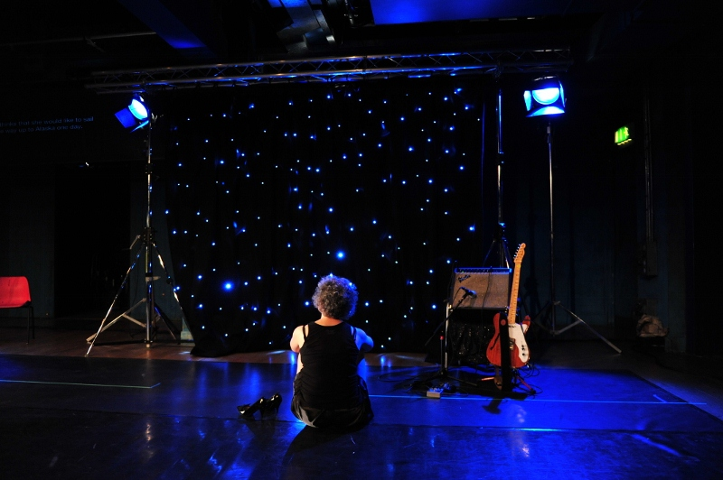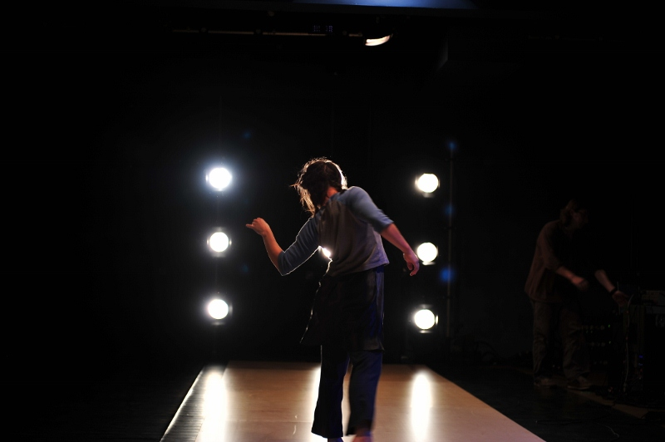

Entitled

“It hums with quiet honesty, unflashy reveals, tender regrets and risk-taking”
The Guardian, July 2011

“A thoroughly enjoyable education in ‘real theatre’ achieved through infinite complexity, raw performances and quiet reflection”.
Whatsonstage, July 2011

“Hugely audacious”
The Stage, July 2011

“What Richard Gregory and his company do is show that mankind is constantly reaching for something beyond its power.”
NRC Handelsblad, Netherlands daily, August 2011

“…There’s something special going on here as Quarantine tries to reach into areas of the theatrical experience others companies ignore.”
The Times, September 2011

Susan & Darren

“Grounded in tenderness and humour, their show may be rough around the edges but has an exceptionally warm centre. Go out of your way to see it.”
Donald Hutera, The Times, May 2010

“At times their closeness is almost unbearable. “What will you miss about me when I’m gone? Susan asks. Most of all, dancing with you,” says Darren.”
Luke Jennings, The Observer, May 2010

“Remade for a new tour, [Susan & Darren] is a brilliant show from the ever-brilliant Quarantine, a company that mines real, artistic gold from the rough, everyday lives of ordinary people.”
Lyn Gardner, Theatre Picks of the Week, Guardian Guide, May 2010

“Susan & Darren feels wonderfully fresh and unscripted: they just talk to us, even when they’re acknowledging how theatrical this is.”
Zoe Anderson, The Independent May 2010

“In this brief 90 minutes they allow us to take part in their lives and you come away feeling like you have known them forever…with a buffet and disco thrown in, this really is a little gem of a show.”
Craig Hepworth, What’s On Stage May 2010

“Words cannot do this living, breathing work justice. Go and experience it for yourself – it may change your life.”
Charlotte Kasner, ballet.co.uk May 2010

“…A beautiful, thought provoking piece of work.”
Joan Davies, Manchester Confidential, May 2010

“There's a moment when Susan looks at Darren and your heart squeezes at the raw honesty of it.” Mary Brennan, The Herald 19 Oct 2007

“It’s intimate, life-affirming, utterly magical and unmissable.”
Noeleen Dowling: Irish Times 2008

“The most heartwarming, vein-thrumming, uplifting show of this Festival.”
Fiona McCann, Irish Times.com

“Striking in its simplicity and moving for its bare honesty. A moving and immensely satisfying night out.”
Jesse Weaver: Irish Theatre Magazine 2008

“It’s not often, at the end of a show, that you long to rush up and hug the performers, but I had to resist the urge after this piece produced by Company Fierce and Quarantine.”
Lyn Gardner: The Guardian 2006

“This not so much a performance as a gift – one that comes straight from the heart.”
Lyn Gardner: The Guardian 2006

“It’s the best night out I can remember. I’m moved, almost to tears, by the honesty, directness, warmth, and clarity in the performance. This is poignancy unadorned. Extraordinary ordinary lives celebrating just being.”
Miriam King: Total Theatre 2006

“One of the most original, intimate, warmly human and movingly open-hearted shows I’ve seen in a very long time... The banal and the beautiful, the tragic and the joyful, exist side by side, just as they do in life, in a marvellous show which is as full of surprises as it is of life-affirming love…”
Kevin Bourke Manchester Evening News, 2006

See-saw

“It just reminds us, in the most potent way possible, that behind every face we pass in the street there beats a life of infinite complexity. In other words, it makes us see others afresh, with a new intensity, humanity and respect; and you can’t ask much more from theatre than that”.
Joyce McMillan: The Scotsman 2000

Butterfly

“The whole thing might be the bastard offspring of the Wooster Group crossed with the Osbournes – radical reality theatre.” Robert Dawson-Scott, The Times
“This piece has genuine heart, humour, honesty and love. Take a hankie and someone to hug”.
Mary Brennan: The Herald 2004

“Quarantine has an impressive reputation for theatre that radically dismantles the conventions by which we normally experience it.”
Claire Allfree: The Independent 2004

White Trash

“Both celebratory and quite extraordinarily moving without being in the slightest bit sentimental. The entire evening has a matter-of-fact lyricism about it.”
Lyn Gardner: The Guardian 2004

“What you see is artfully directed and utterly authentic, a show within a show - because the seven are finding themselves as they perform, because their performance is their triumph, their nightly act of self-definition. In short, you're not told what happened; you're there as it happens.”
Peter Preston: The Guardian 2004

Something a taxi driver in Liverpool said…

“Theatre for the soul”
BBC Northern Ireland

Company Information: Quarantine

Quarantine creates theatre, performance and other public events.

Our work is about the here and now. In its form, content and process of creation, it examines the world around us.

Past projects have included shared meals, family parties and a journey in the dark for one person at a time - as well as performances on stage, watched by audiences in seats.

Established in Manchester and now based in Salford, Quarantine was set up in 1998 by directors Richard Gregory and Renny O’Shea with designer Simon Banham. For more information about the company go to www.qtine.com.

Media Available

Entitled Trailer, .flv, 7.6MB
An invite to Dropbox to enable access to the folder where the file is stored is available by mailing sam@qtine.com or for access via YouTube go to http://www.youtube.com/watch?v=d0Sm3q4ROmU

Production shots and publicity images are available in print and web size in the Dropbox folder also.

Social Media Connections

Facebook FanPage:

www.facebook.com/QtineMcr

Twitter:

@QtineMcr

Please ‘like’ us and ‘follow’ us and we will reciprocate. Please email sam@qtine.com with details of your Facebook and Twitter feeds.

Entitled has been previously seen at:
Festival de Otoño en Primavera, Madrid; Festival a/d Werf, Utrecht; LICA, Lancaster; Curve, Leicester; Aberystwyth Arts Centre, Aberystwyth; Sadler’s Wells, London; LPAC, Lincoln; ICIA, Bath; Northern Stage, Newcastle; Summerhall, Edinburgh; Noorderzon Performing Arts Festival, Groningen; Royal Exchange Theatre, Manchester.

